Connecting Canvas Account to your

McGraw Hill Connect account

Log on to Canvas and click on your course card for Financial Accounting.
Then in the Course Navigation on the left side menu. Click on McGraw Hill Connect, click on the BEGIN button in the Connect registration window. This will take you to McGraw Hill site for our class.

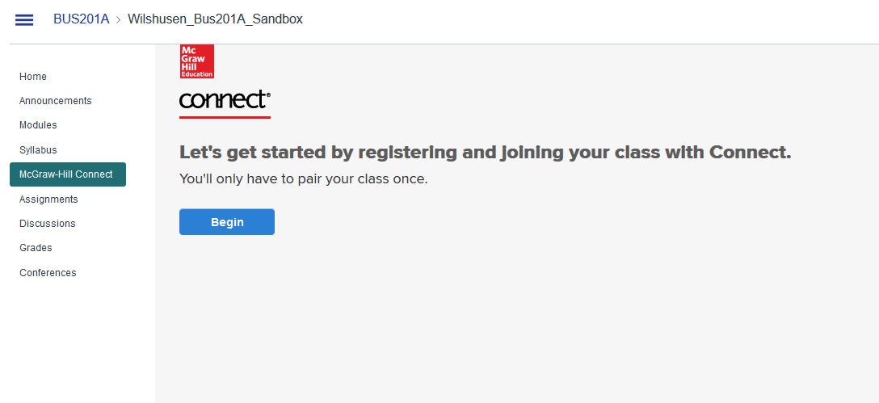
If you have used Connect before in another class, enter your email address and password then click Sign In.
If you are new, click on the register button to create a log on. Please use your mycuesta email address and password to keep things easy to remember, and ensure an easy connection.

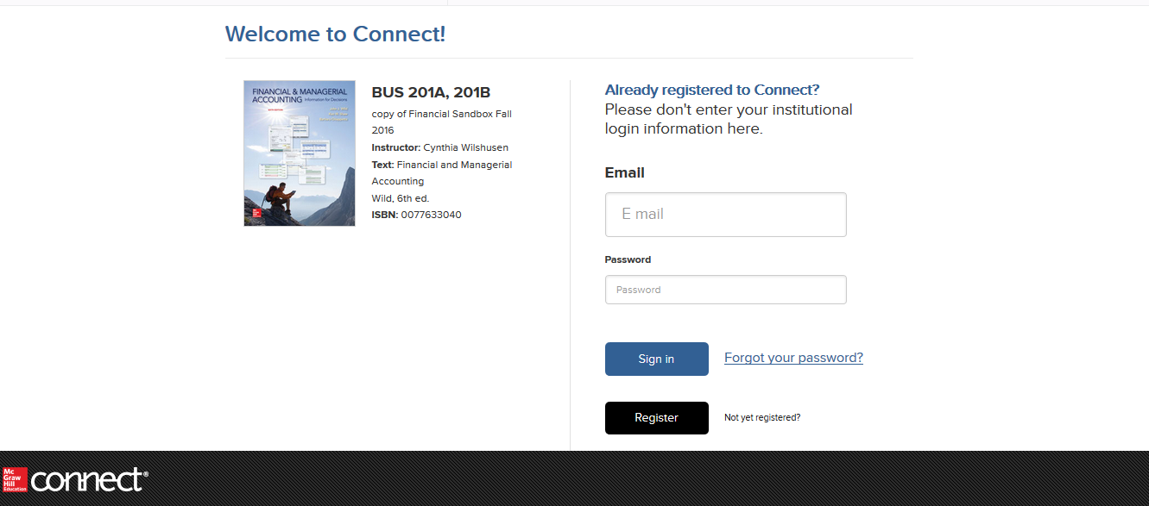

Follow the step by step instructions to sign up for the class. Use the registration code provided with your book or if you don’t have your book yet, you can purchase an access code online (if you don’t need a physical book and wish to use the eBook), or use the 14-Day trail or to purchase the combo.
BE SURE TO USE YOUR CUESTA EMAIL ADDRESS WHEN YOU SIGN UP OR YOU WILL NOT BE ABLE TO VIEW YOUR GRADES IN CANVAS!!!

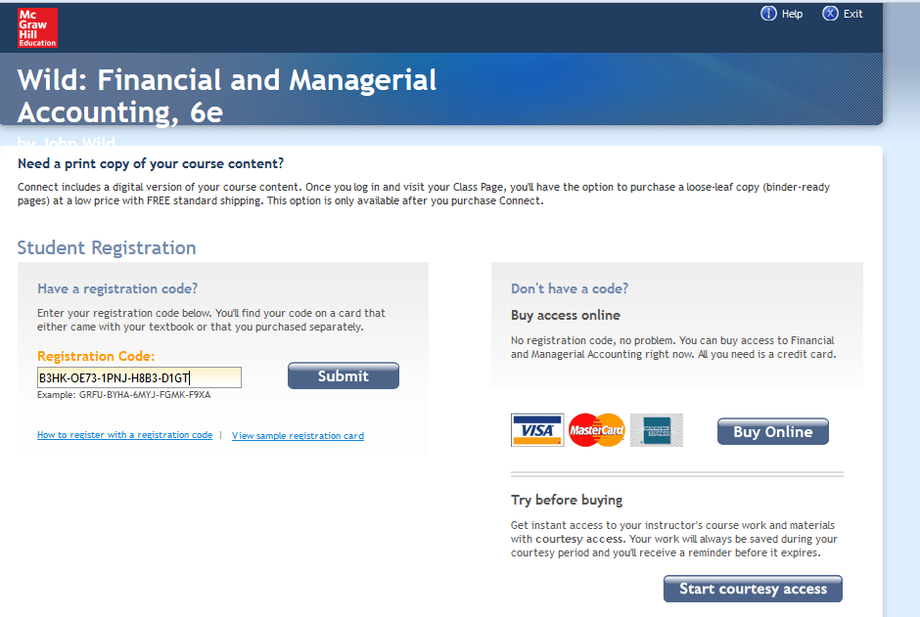

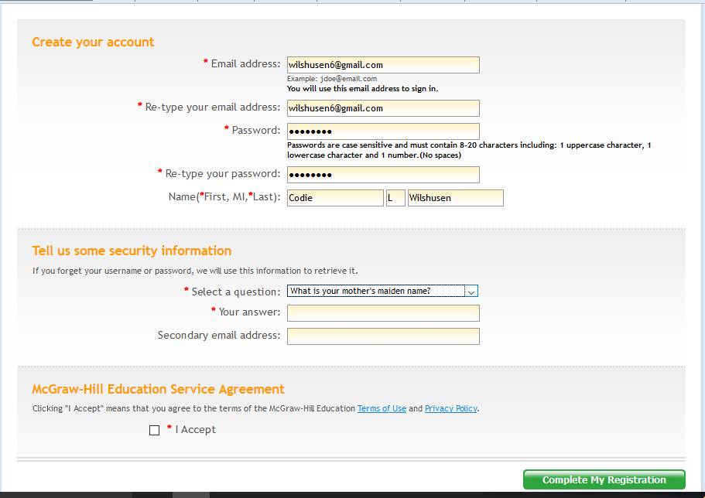
Congratulations you are now CONNECTED!!!! Click Go to Connect
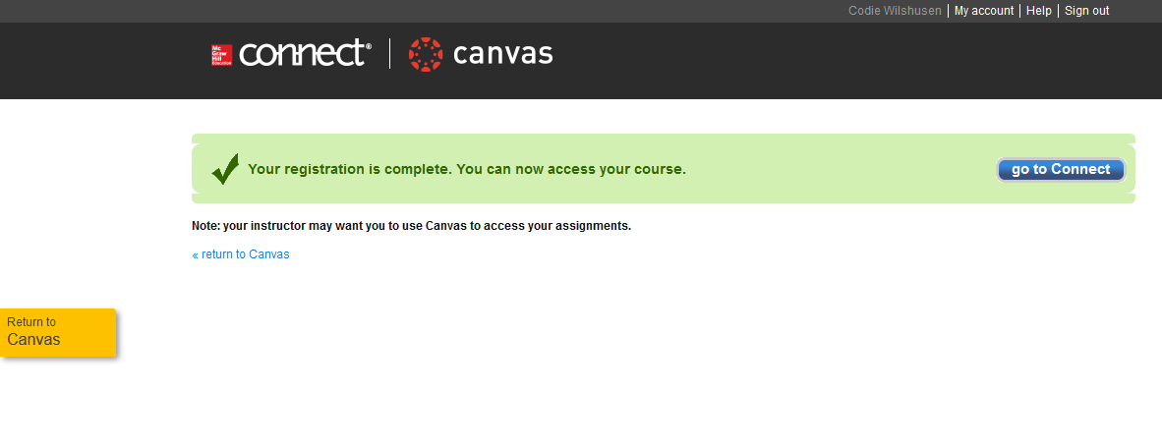

Everyday log into your course using Canvas log in, then click on the McGraw Hill Connect to access your homework. Click on the go to my connect section.
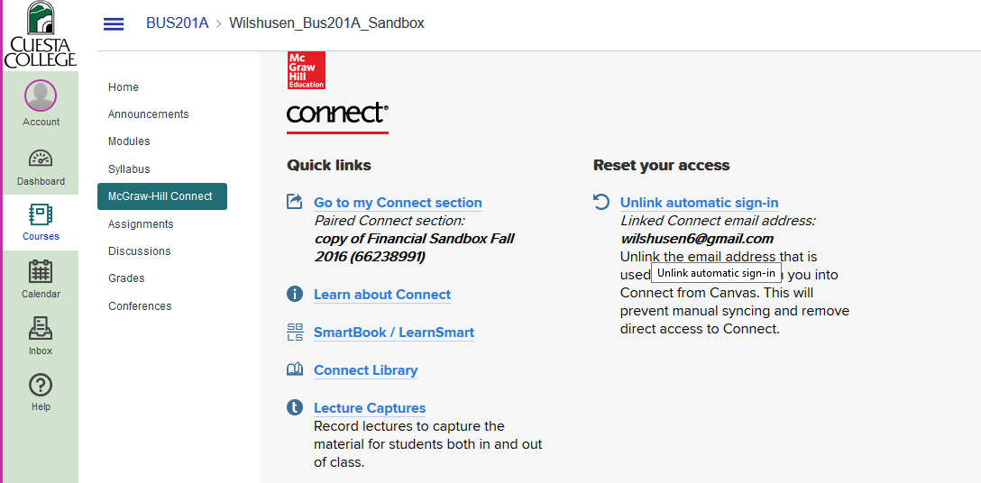

When you have completed your assignment, make sure you click the Return to Canvas on the left hand side to save your work and have it returned to canvas gradebook.
