**Connect**® 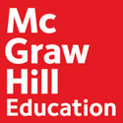

**Canvas**

**with Deep Integration**

**Student Registration**

**Step 1:** Sign into Cuesta College Canvas Instructure: [**https://cuesta.instructure.com/**](https://cuesta.instructure.com/)

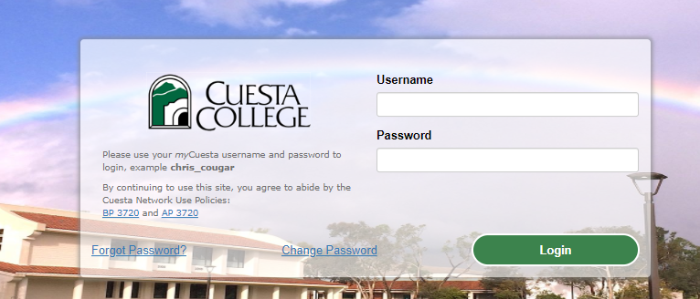

**Step 2:** From your **Dashboard** or ***Courses***, click on course name.

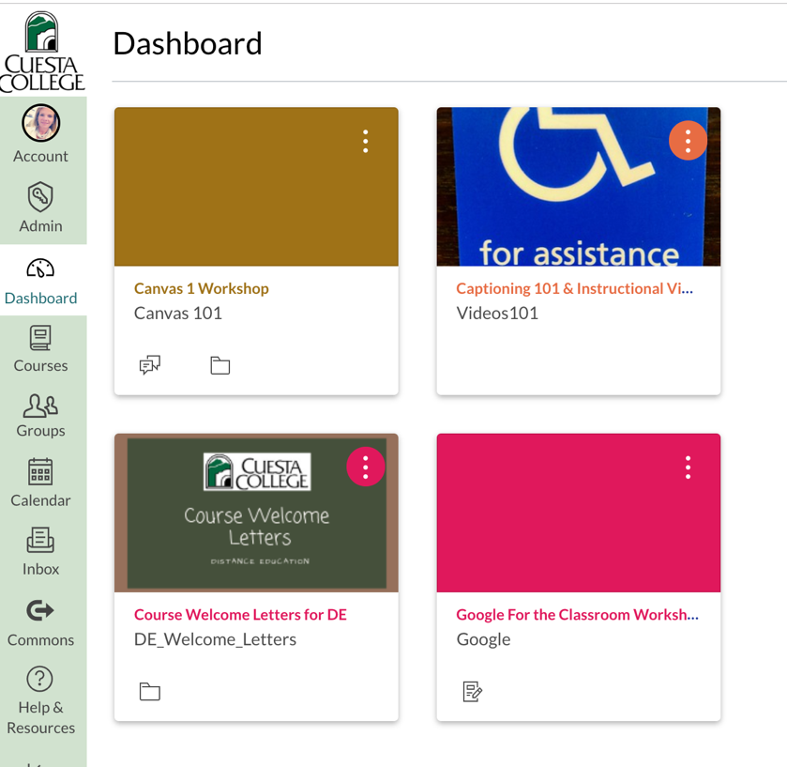

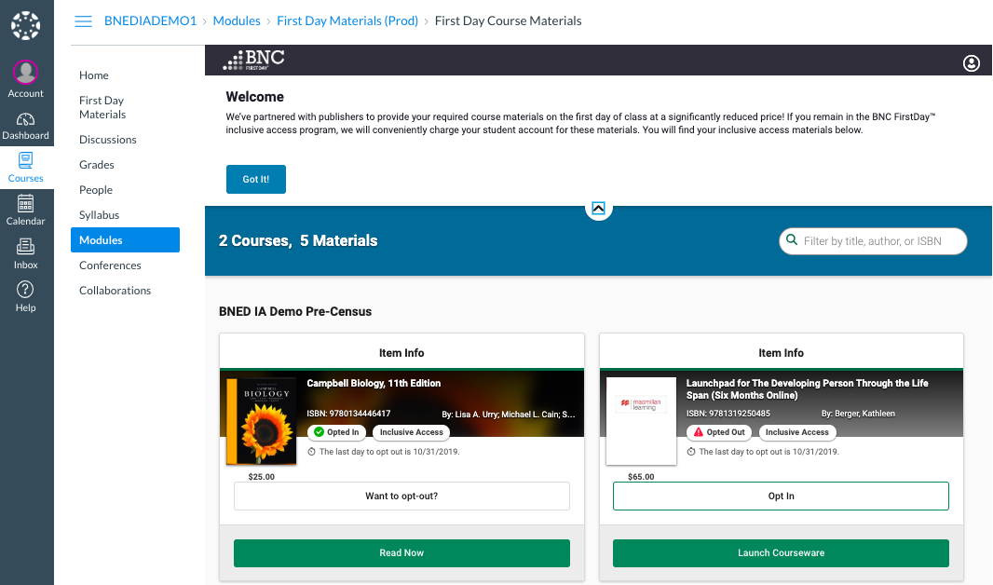**Step 3:** On Canvas course home page, start the registration process by clicking the Course Materials link on your left course navigation bar. This will launch the Barnes and Noble bookstore. You will see a welcome message and all your first day courses you are enrolled in.

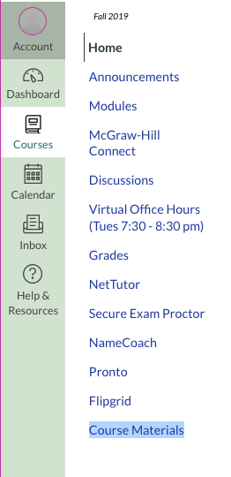

*NOTE: Make sure you* ***do not*** *select the Opt Out option. This will not allow you to purchase your course materials for the course. If you have questions or are taking the course again contact your instructor before opting out.*

**Step 4:** Click the Reveal Access code for your materials, then click the Copy button when the code is revealed. This will save the code to your clipboard so you can paste it into the publisher registration (see below).

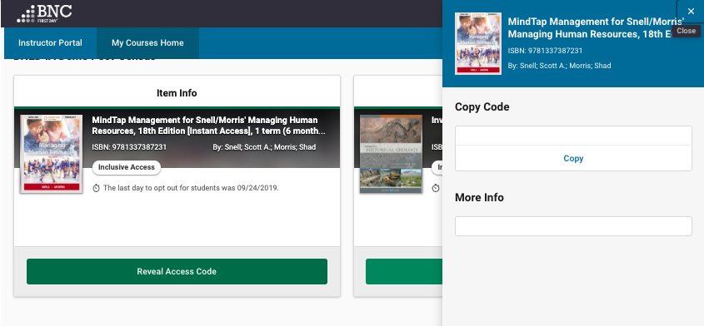

**Step 5:** Click on the McGraw-Hill Connect Button OR by clicking on your first assignment (under Assignments or Modules depending on how your instructor has set up their course) ​

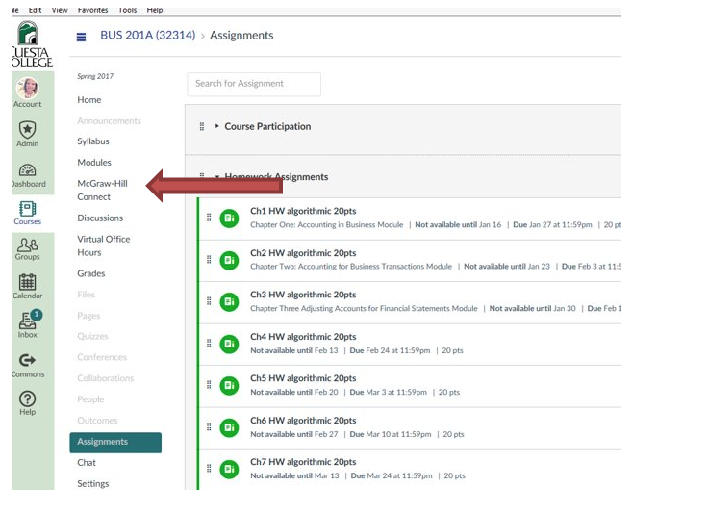

**Step 6:** Click on ***Begin***.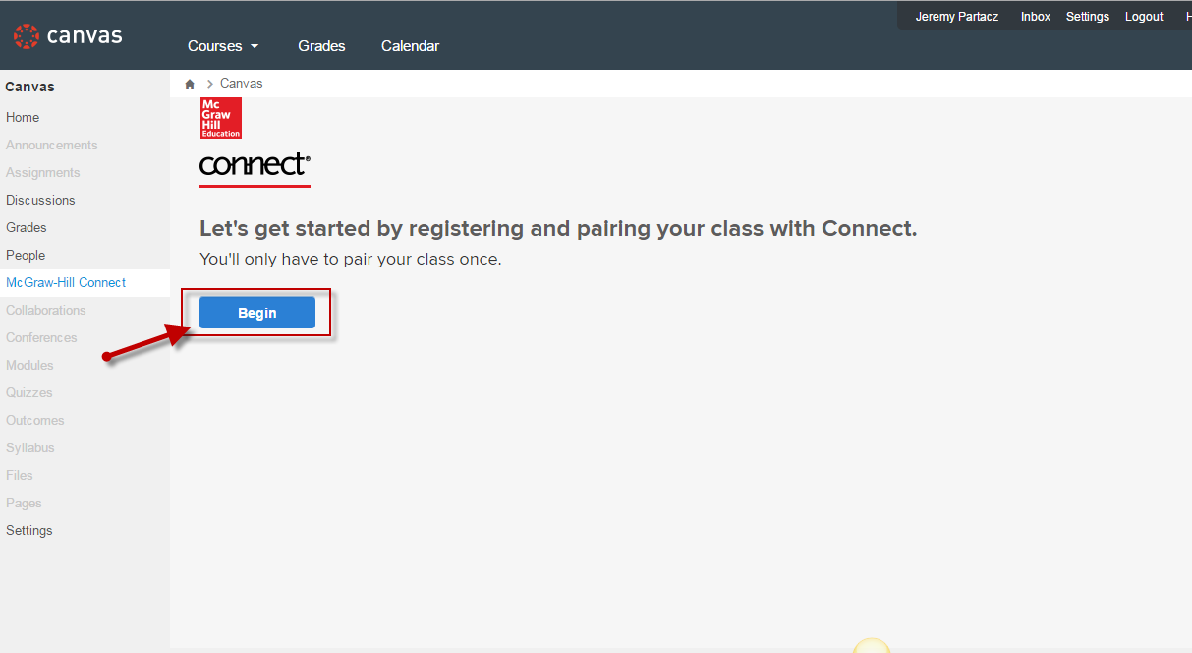

**Step 7:** Enter your email address.

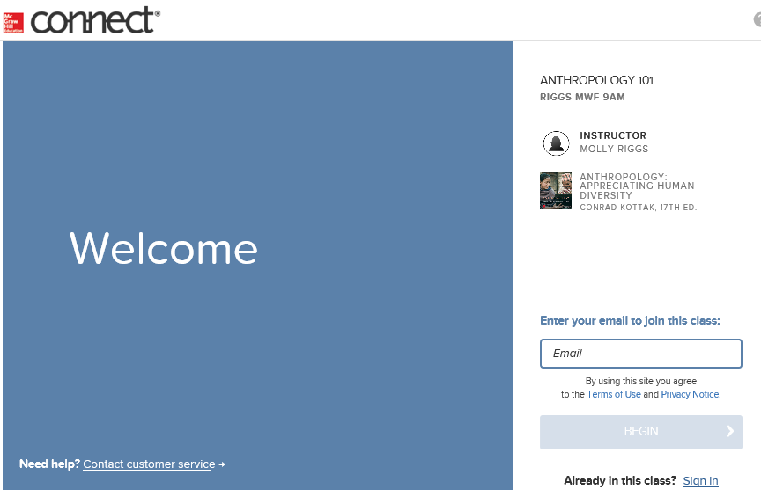

**Step 8:** If you **do not have a Connect account**, you will be prompted to create an account. **We recommend using your school/institution email address when creating an account.**

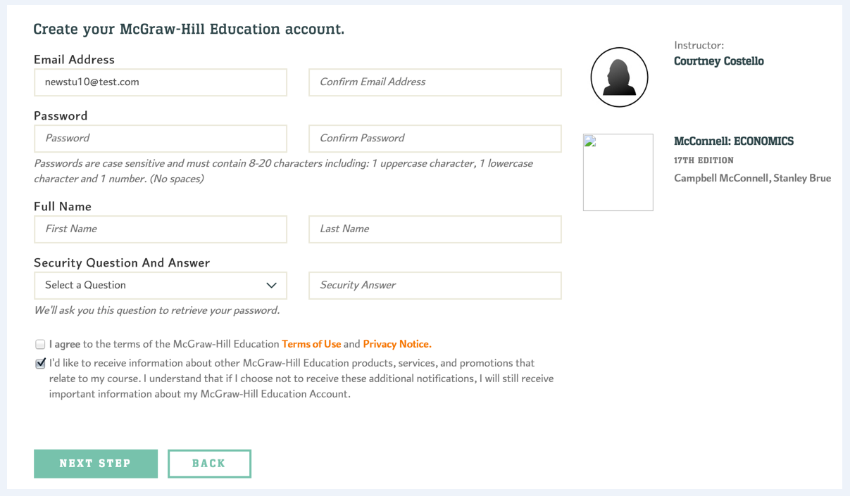

If you **have an existing Connect account**, you will be prompted to enter your Connect password. If you receive the message, **“You have a Connect Account”** but have forgotten your password, **click Forgot Password**.

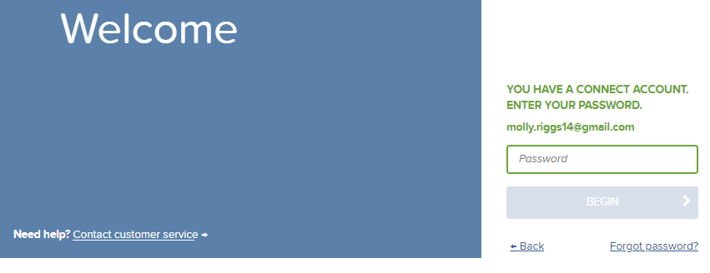

**Step 9:** **Paste your access code (use keyboard ctrl+V or Command+V), then Click** ***Confirm***.

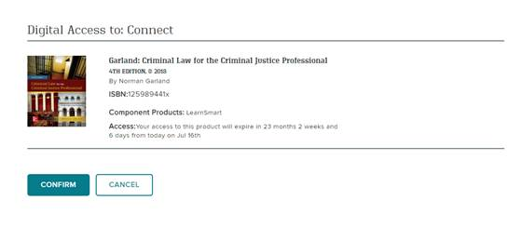

**Step 8:** You have successfully joined the class. **Click** ***Go To Connect***. 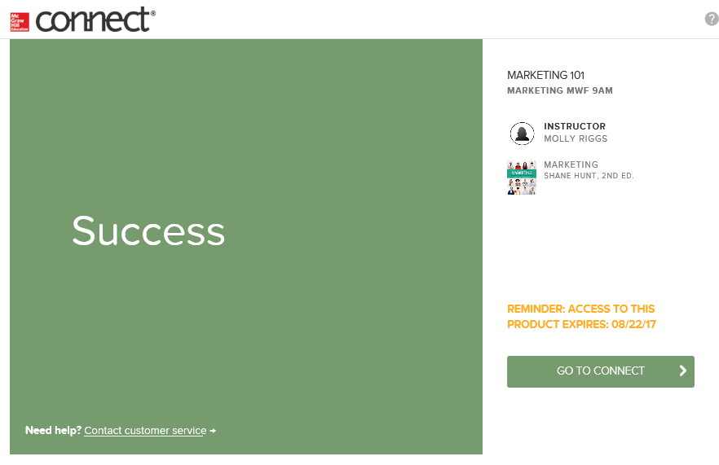

# Connect Billing:

By following this registration process, you will automatically have access to the course materials on Day One without entering a code or being charged upfront.  After the Cuesta add drop date, your student bursar account will be billed at a discounted rate for the required course materials representing significant savings for you as the student.  If you choose to not have your account be billed, you must “opt out” before the required deadline.  If you do not opt out, you will be charged.  We highly recommend you do not opt out if you are going to continue in this course because this is the lowest cost available for Connect.  After you have paid for the product, you will have access for the remainder of the term.

**Need Help?**

**Tech Support & FAQ**

**Cuesta College Support:**

**Email:** [support@my.cuesta.edu](mailto:support@my.cuesta.edu)

**Cuesta College Support Hours of Operation  
Monday – Thursday:** 7:30 am-9:00 pm PST **Friday:** 7:30 am-4:00 pm PST

**McGraw Hill Support**

**Call:** (800) 331-5094

**Email & Chat:** mhhe.com/support

**Monday–Thursday:** **24 hours**

**Friday:** 12 a.m. – 9 p.m. EST

**Saturday:** 10 a.m. – 8 p.m. EST

**Sunday:** 12 p.m. –12 a.m. EST