Econ 220: Personal Financial Planning, CRN 74549
Welcome Letter/Syllabus Fall 2022
Instructor: Susan Iredale Kline
e-mail: susan_kline@cuesta.edu

Welcome to Personal Finance! My name is Susan Kline, and I will be your guide (aka your instructor). I also teach Principles of Economics (both Macro and Micro) here at Cuesta College. Before I did that I sold life insurance, and worked for an investment bank where I got my Series 7 and 63, which are fancy exams that let you be a stock broker. My graduate degree is economics, but my undergraduate degree was finance. I’ve been interested in the stock market all of my adult life, but this classis about more than the stock market. Because of my background various people I know have asked me lots of random finance questions, and this class is my way of trying to impart a lot of the knowledge I have to others in the hopes of making you confident in managing your own finances, and feeling secure about your decisions. So let’s get started….

Course Description: This course covers the management of income and spending by creating a personal plan using effective financial planning tools. Topics include creating a budget, using credit wisely, making informed insurance decisions, and an overview of different financial assets used for personal investing.
There are many broad topics in this course, not all may apply to your financial situation today, but this course is less about today and more about preparing for your financial future.
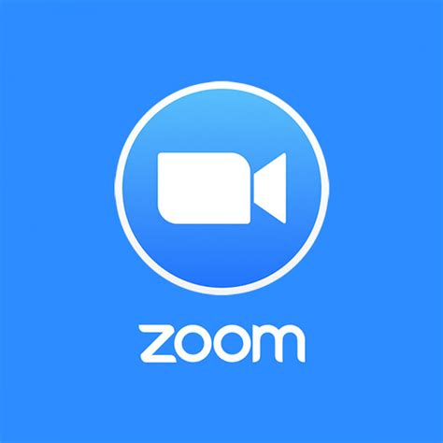
Weekly Lecture via Zoom: Wednesday 1:00 to 2:20pm
Log-in information can be found in the “Getting Started” Module in Canvas. Lectures will count towards the participation grade and attendance will be taken via Zoom poll. Students unable to attend the Zoom session live will be given a discussion question (noted DURING the recorded Zoom session) and answer that question to get participation points for the week.
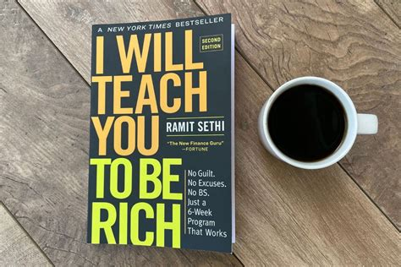

Required Reading: I Will Teach You to be Rich, 2nd edition by Ramit Sethi available as a mass-market paperback (even try your local library, or send me an email if you’re having trouble getting a copy) as well as various articles and instructor written pages in Canvas.

Student Learning Outcomes Students will be able to:
- Identify personal financial goals and develop strategies to meet those goals.
- Analyze various investment options, account types, and other financial tools that can be used to help individuals reach their financial goals.

Grades
Participation (Attendance/Discussion Posts) | 15%
Projects/Activities | 70%
Reading Quizzes | 15%

90% + | A | 70-79% | C
80-89% | B | 60-69% | D

Projects
There are five required and one optional project (meaning extra credit) in this course. More information about each of the assignments listed below is available via Canvas.
1. Identifying your financial goals. (Week 2)
2. Creating a budget. (Week 4)
3. Understanding Insurance plans (Week 10)
4. Following the Stock Market (Week 13)
5. Determining your retirement income needs (Week 15)
6. Track your Expenses for 30 Days (Optional - due by end of term)

Projects will be due on Mondays before 5:00 pm.

Participation - Zoom Attendance & Discussion Posts
There are sixteen weeks for this course. Students will get five points for attending lectures each week via Zoom (attendance taken via Zoom polls). Students who are unable to attend Zoom lecture will have an additional discussion post - the question for which will be found in the recorded Zoom lecture posted that week. (Eighty points for the semester).

College Policies / Assistance (aka Course Fine Print)
Instructor Contact Expectations: The best and fastest way to contact me is by email. I will generally respond to your emails within 24 hours during the workweek. E-mails sent after 4 pm on Friday are not likely to be answered until Monday morning.

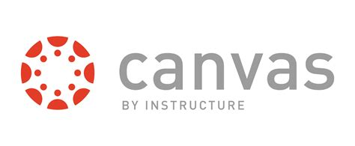
Course Environment: This online course will be using the web-based learning management system Canvas as the method to disseminate information. Canvas provides the framework for the course including written pages, links to articles, podcasts, or videos or other files, the tools to receive and send course materials, and a grade book. Using the communication tools, you can communicate using email, and you can share materials and ideas with other course participants via discussion forums.

Online Learning: If you have never taken an online class or this is your first experience with Canvas, please be patient with yourself. Online classes are not inherently easier, although they may be much more convenient for many students. You should expect to spend at least as much time, if not more on this course as you would on a course that meets face to face. Since there is less time devoted to the lecture, much of this time will be self-directed and there will be a substantial amount of reading, viewing, studying, and writing required. This course is completely online using Canvas; all coursework (discussions, assignments, quizzes) is submitted online. There are no face-to-face meetings. Please be prepared to spend 6 - 12 hours per week on coursework for this class.

IS AN ONLINE CLASS FOR YOU? First, go to the Online Readiness Resources and take the "self-assessment " and review all the resources that were designed to help you understand the basis for an online class and the skills necessary for success. (If the tutorials do NOT describe you, then taking this class online is NOT for you and I strongly suggest that you drop the online class and enroll in a traditional classroom section.)

Regular Effective Contact policy: Regular and Effective Instructor Contact will be met through weekly instructor initiated threaded discussion forums; weekly announcements to students; timely and effective feedback on student assignments; email or messaging to individuals; and virtual office hours.

Each student is required to follow all school guidelines and comply with all school deadlines including personal responsibility for adding and/or dropping this class. Drop dates are available on the academic calendar http://academic.cuesta.edu/admrreg/infodate.htm.
Each student is responsible for all information in posted announcements, the syllabus and assignments for the course.

Academic Honesty: Students are responsible for being aware of and complying with the Academic Honesty Policy (refer to Cuesta College Schedule or Cuesta College Catalog). At the discretion of the instructor, students being academically dishonest (submitting another student’s work as your own, e.g. copying a computer file that contains another student’s work) will be dropped from the course. If the drop deadline has passed, students will receive a failing grade in the course. In addition, a “Student Incident Report” will be filed with the Vice President of Academic Affairs office.

Students With Disabilities: If you have a disability and need accommodations in this class, please contact Disabled Student Program & Services at (805) 546-3148 or (805) 591-6215 NCC as soon as possible to ensure that you receive the accommodations in a timely manner. You may also discuss your need for accommodations with the instructor.

Veteran: If you are a Veteran, please contact Karen Andrews, Cuesta College’s VA Certifying Official - 546-3142. The Veteran Center is in room 6903. The Veteran Center hours are Mon. - Thurs. 9:00am to 4:00pm. Link to Veteran Services webpage.

Counseling Center: College life can compound other issues in one’s life. If you are feeling overwhelmed and feel you need help to maintain your personal balance – please contact our counseling center at 805-546-3138.

Library Services: Circulation/Reserves: (805) 546-3155 Reference Desk - SLO: (805) 546-3157 NC: (805) 591-6200 Ext. 4410.
Library hours: SLO Campus: Monday - Thursday: 8:00 am - 8:00 pm, Friday: 8:00 am - 4:00 pm, Saturday & Sunday: Closed.
NC Campus: Monday & Thursday: 8:30 am - 7:00 pm, Tuesday & Wednesday: 8:30 am - 8:00 pm, Friday, Saturday & Sunday: Closed.

Tutorial Services: Promoting the academic skills, learning strategies and attitudes necessary for student success in all disciplines for ALL students. Hours: SLO: 9:00 am - 4:30 pm, Room 3300 NCC: 8:00 am – 5:00 pm, Room N3130. Student success webpage

Course Calendar (Subject to revisions as necessary/appropriate)

Wk | Wed | Module | Paperback Reading | Canvas Pages
1,2 | 9/8/2021 | Financial Goals | Rich, Intro | Introduction to Personal Finance and Writing Financial Goals
3 | 9/15/2021 | Budgeting | Rich, Ch. 4 | Introduction to Financial Statements
4 | 9/22/2021 |  | Rich, Ch.5 | Time Value of Money & Inflation, Where to Save Money?
5,6 | 10/6/2021 | Taxes | Video: "Your Tax Dollars at Work" (5:58) | Taxes
7 | 10/13/2021 | Credit/Loans | Rich, Ch. 1 & pg. 315 - 332 | Making Large Purchases, Borrowing Money, Using Credit Cards
8 | 10/20/2021 | Insurance (Health, Property/Car, Life) |  | Introduction to Insurance
9 | 10/27/2021 |  |  | Property Insurance (Renters or Homeowners), Car Insurance
10 | 11/3/2021 |  |  | Health Insurance, Life Insurance
11 | 11/10/2021 | Financial Investing (Stock Market) | Rich, Ch. 3 | How to Read a Stock Chart
12, 13 | 11/24/2021 |  | Rich, Ch. 6, 7 | What is Cryptocurrency?
14 | 12/1/2021 | Retirement & Estate Planning |  | Retirement Planning
15 | 12/8/2021 |  |  | Estate Planning

Key: Rich = I Will Teach You to be Rich, 2nd edition by Ramit Sethi
